**CHAPTER 1**

**Gyroscope:** <https://www.youtube.com/watch?v=cquvA_IpEsA>

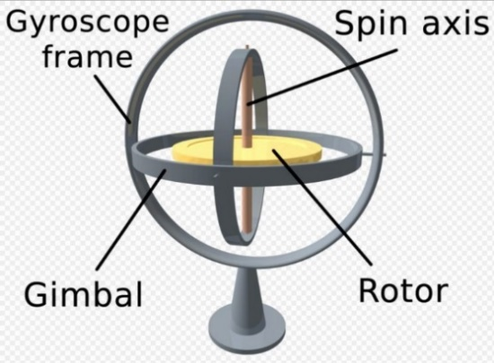

Spinning gyroscope resists the change in its position i.e. resistive force appears when attempt is done to tilt or rotate the gyroscope.

**Angular momentum:**

r⃗ is the particle position and p⃗ = mv⃗ is **linear momentum**   with respect to the origin.

**The angular momentum** l⃗ of a particle is defined as the cross-product of r⃗ and p⃗, and is perpendicular to the plane containing r⃗ and p⃗:

l⃗ =r⃗ ×p⃗

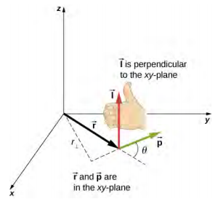

The direction of the angular momentum is perpendicular to the plane containing r⃗ and p⃗ **which is similar to choosing** the direction of torque to be perpendicular to the plane of r⃗ and F⃗.

* Angular momentum arrow always indicates the axis around which the object is rotating.

**Oil Pressure:**

Oil pressure in a car is measured as the resistance to flow between the oil pump in the oil pan and the bearings in the crankshaft. If it is actually too high, it means you are not getting enough oil through the bearings to keep your engine from self-destructing.

The colder your engine, the higher your oil pressure, as the oil is still much thicker than it will be at operating temperatures. Typically, on startup, you will have 40 to 60 psi, which will drop to ranges listed above once the engine heats up.

**Head Mounted Display:**

It shows flight information like airspeed, altitude, AOA, other standard things to fly properly and also weapon information on air to air targets, air to ground targets, how far, where they are, what type they are (friend, enemy, unknown). Weapon pointing capability everywhere pilot look.

Picture in picture feature i.e. capability of what is happening in the ground (live video).

Allows to see full 360 degree areas. Integrated night vision nowdays.

**Flight Control Surfaces:**

Aircraft flight control surfaces are aerodynamics devices allowing a pilot to adjust and control the aircraft’s flight altitude.

Main control surfaces are Aileron, Elevator, Rudder, flaps, slats, airbrakes, rudder and aileron trim.

**Aircraft flight control *system*:**

A conventional fixed-wing aircraft flight control system consists of *flight control surfaces,* the respective cockpit controls, connecting linkages(levers) and the necessary operating ***mechanisms*** to control an ***aircraft’s direction*** in flight. Since, aircraft engine change speed they are also considered as aircraft flight controls.

Flight control system consists all parts that are responsible for the change in altitude, direction, speed and all mechanisms for that operation.

Primary Control:

Cockpit controls: Control yoke (control column), center-stick or side-stick (joystick), governs roll and pitch by moving ailerons and elevator.

Rudder pedals

Throttle controls to control engine speed or thrust.

Secondary control:

Trim tab, Flaps, air brake, spoiler, leading edge slats and variable sweep wing.

Flight control systems:

1. Mechanical
2. Hydro-mechanical
3. Fly-by-wire.

**Ram air:**

Ram air is the airflow created by a moving object to increase ambient pressure. The purpose of a ram air system is to increase engine’s power. Used in cooling but in airplane it is combined with avionics and pilot sensors to provide information like the airspeed of the aircraft.

**Air data system:**

An Air Data Computer or Air Data System in an aircraft is a computer that takes static air pressure, ram air (air with velocity I think) pressure, temperature and other factors into consideration to determine, among other things, the true airspeed, calibrated airspeed, instantaneous vertical speed change, and altitude.

Airspeed in a high-performance aircraft is tougher to determine than you might think.  As the aircraft ascends into the rarefied atmosphere, the ambient pressure falls and the normal airspeed sensor (the pitot tube) measures fewer and fewer air molecules hitting it rendering a slower and slower "indicated airspeed."  So, indicated airspeed of aircraft is different from true air speed. (by myself)

**Stand**-**alone** : self-contained especially : operating or capable of operating independently of a computer system

**Trim: (Secondary Flight Control)**

To **"trim"** an aircraft is to adjust the aerodynamic forces on the control surfaces so that the aircraft maintains the set attitude without any control input (primary control surface).

**CHAPTER 2**

**Elastic energy:** (RELATED TO FLAW DETECTION (CRACK) IN SKIN)

It is the energy stored in the material or physical system as it is subjected to elastic deformation by work performed upon it. Elastic energy occurs when objects are impermanently compressed, stretched or generally deformed in any manner.

**Acoustic: (relating to sound or the sense of hearing)**

**Acoustics** is the branch of [physics](https://en.wikipedia.org/wiki/Physics) that deals with the study of all [mechanical waves](https://en.wikipedia.org/wiki/Mechanical_wave) in gases, liquids, and solids including topics such as [vibration](https://en.wikipedia.org/wiki/Vibration), [sound](https://en.wikipedia.org/wiki/Sound), [ultrasound](https://en.wikipedia.org/wiki/Ultrasound) and [infrasound](https://en.wikipedia.org/wiki/Infrasound).

When we talk, the air vibrates and the compression and rarefaction region are formed and the wave travel through medium through compression and rarefaction. In compression region, pressure becomes maximum and density is high.

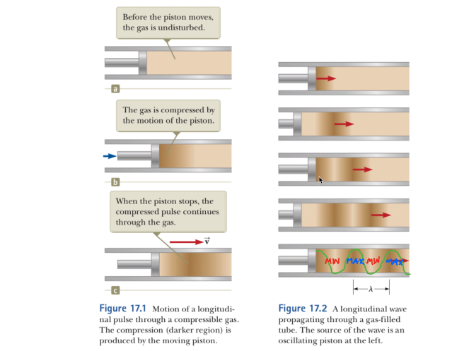

In first figure, the piston is moved forward which strikes fluid to the right and the fluid are pushed into each other and more fluid particles are present there, this high pressure region is transferred to the right.

After, moving forward the piston is then moved back then the gas in front of it expands and pressure and density decreases below their equilibrium values and then rarefaction region is formed.

Again, piston moves forward and then backward so the high- and low-pressure region are formed which is moving toward the right side. Min, max, min, max pressure regions are formed and this behavior is described by sine wave.

In this way, longitudinal or mechanical waves are formed where the particle motion is along the direction of motion of wave.

**Acoustic Emission:**

Acoustic Emission refers to the generation of elastic waves produced by a sudden redistribution of stress in a material. When there is a crack and the external force (change in pressure, load or temperature) is applied then the maximum stress occurs at the end of the crack and the stress redistribute when the external force is released.

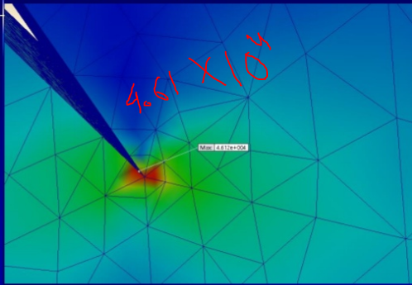

|  |
| --- |
|  |
| |  |  |  |  | | --- | --- | --- | --- | |  | |  | | --- | | **-** | |  | | **Introduction to Acoustic Emission Testing**    Acoustic Emission (AE) refers to the generation of transient elastic waves produced by a sudden redistribution of stress in a material. When a structure is subjected to an external stimulus (change in pressure, load, or temperature), localized sources trigger the release of energy, in the form of stress waves, which propagate to the surface and are recorded by sensors. With the right equipment and setup, motions on the order of picometers (10 -12 m) can be identified. Sources of AE vary from natural events like earthquakes and rockbursts to the initiation and growth of cracks, slip and dislocation movements, melting, twinning, and phase transformations in metals. In composites, matrix cracking and fiber breakage and debonding contribute to acoustic emissions. AE’s have also been measured and recorded in polymers, wood, and concrete, among other materials.  Detection and analysis of AE signals can supply valuable information regarding the origin and importance of a discontinuity in a material. Because of the versatility of Acoustic Emission Testing (AET), it has many industrial applications (e.g. assessing structural integrity, detecting flaws, testing for leaks, or monitoring weld quality) and is used extensively as a research tool.  Acoustic Emission is unlike most other nondestructive testing (NDT) techniques in two regards. The first difference pertains to the origin of the signal. Instead of supplying energy to the object under examination, AET simply listens for the energy released by the object. AE tests are often performed on structures while in operation, as this provides adequate loading for propagating defects and triggering acoustic emissions. |  | |

When a component is stressed, the built-up state of stress spontaneously discharges at a leak, thereby generating sound impulses.

The energy thus discharged is received by sensors applied on the surface of the tested object.

The signals are received at different times by different sensors. By measuring these differences in time, the sound source can be located. One of the major advantage of AET is the possibility to test pressure equipment during plant operation or during downtimes caused by leaks, corrosions or defects of the material.

The reliability of the information obtained through AE on the structural integrity of the tested object is greater than that of more conventional testing methods.

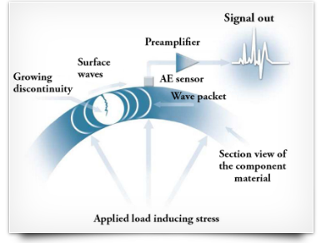

Crack generates acoustic emission as they grow and there are series of sensors present that accurately detect these emissions to determiner the location of the damage.

**Data Concentrator Units:** <https://astronautics.com/products/displays/data-concentrator-unit/>

Data Concentrator Unit (DCU) collects and converts analog flight data into informative digital readouts for aircraft pilots. The DCU provides real-time data such as engine and transmission oil pressure and temperature, allowing pilots to know the exact performance of the aircraft’s systems at any given moment.

DCUs is composed of analog-to-digital and digital-to-digital conversion devices which can interface with engine temperature, pressure and RPM sensor, providing digitalization values of all engine, hydraulic and power plant sensors. Converts all inputs into a digital format.

Analog inputs include Strain gauge, tachometer (rpm) frequency inputs, etc.

Process engine tachometer, inlet turbine temperature, fuel quantity, fuel low, engine oil pressure, prop tachometer, hydraulic pressure and warning and annunciation.

The units receive a diverse assortment of discrete, analog and digital inputs, which are processed and formatted for use by various aircraft systems.  Each unit is capable of supporting multiple independent, self-contained processors. To provide redundancy, two DCUs are installed per aircraft.

The compact units may be tray mounted or mounted directly to the air frame. DCUs do not have to be removed for data access when Operation Flight Program Software is used to remotely download data by way of Ethernet via the ARINC 615 protocol. In a typical setup, two connected DCU units work in parallel to provide a fault-tolerant system for collection and distribution of inputs and outputs.

**Synthetic vision System:**

Allows the pilot to see the 3d representation of terrain, obstacles and traffic in spite of being cloudy, dark. So, at any situation pilot can have situational awareness of his surroundings even it the dark. This system displays a synthetic terrain and flight hazard including traffic and obstacles as well as a flight path marker and highway in the sky technology.

Ed terrain presentation is almost as real as directly looking at a ground feature, hills and valleys, rivers and lakes. Hills and mountains becomes larger when you get closer to them. Images are much more realistic presentation then a static symbol. This system also use the terrain proximity, where terrain is represented by may be yellow and red, yellow represent terrain is present bellow 1000 feet and red means terrain at less than 100 feet below aircraft.

Obstacle data is updated every 30 days and terrain data every 1 year.

**Highway-in-the-sky:**

The HITS display will project a pre-planned course "highway" for the pilot to follow, instead of gauges and dials for the pilot to interpret and synthesize into a mental picture of the airplane situation. HITS creates box-shaped outlines on the primary flight display (PFD), which vary in size to depict a flight path perspective in front of the aircraft. To follow the flight path the pilot simply "flies" the flight path marker (an airplane symbol) through the boxes.

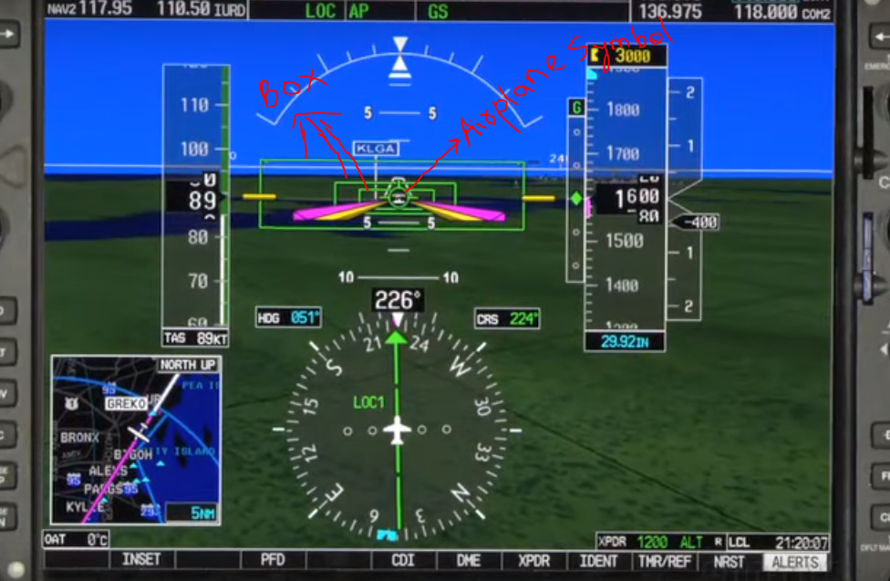

**Raster Graphics:**

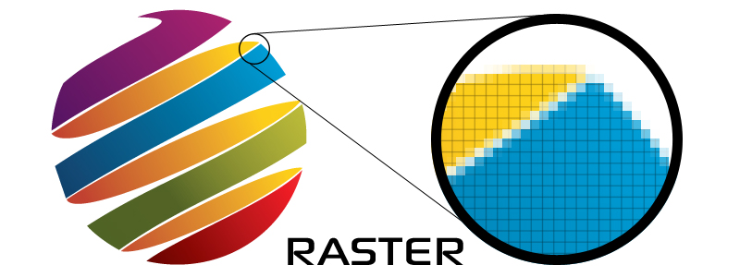

Raster graphics render images as a collection of countless tiny squares. Each square or pixel is coded in a specific color (hue) or shade. Individually, these pixels are worthless but together, they’re worth a thousand words.

Non-line art images are best represented in raster form because these typically include subtle chromatic gradations (as color gradually decrease from i.e. transition of dark to bright is smooth), undefined lines and shapes, and complex composition. Common raster formats include TIFF, JPEG, GIF, PCX and BMP files.

**Vector Image:**



Unlike pixel-based raster images, vector graphics are based on mathematical formulas that define geometric primitives such as polygons, lines, curves, circles and rectangles. Because vector graphics are composed of true geometric primitives, they are best used to represent more structured images, **like line art** graphics with flat, **uniform colors**. Common vector formats include AI, EPS, SVG, and sometimes PDF.

Further, unlike raster graphics, vector images are not resolution-dependent.

**Head Up Display:**

**First-generation HUDs** used a cathode-ray tube (CRT) display to generate images on a phosphor screen. Many HUDs still in use today are CRT displays, but the phosphor screen coating degrades over time. Next-generation HUDs introduced the use of solid-state light sources such as light-emitting diodes (LEDs), modulated by a liquid-crystal display (LCD) screen to display images.

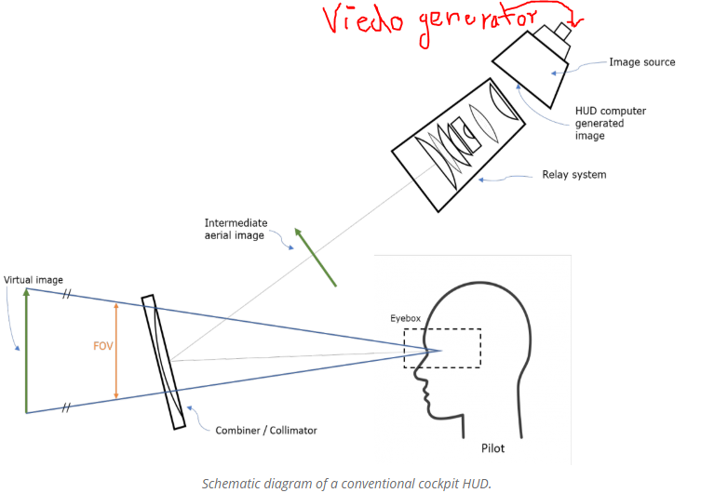

A typical HUD contains three primary components: a *projector unit*, a *combiner*, and a *video generation computer***. (Figure page number 17 pdf)**

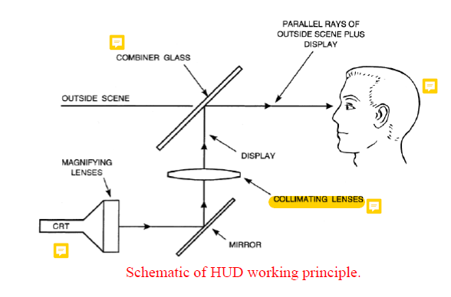

The relayed display images are then reflected through an angle of near 90◦ by the fold mirror. The function of the fold mirror is to enable a compact optical configuration to be achieved so that the HUD occupies the minimum possible space in the cockpit

‘Collimating’ is the process of accurately aligning light or particles in a parallel fashion. For light measurement, this ensures that the light has minimal spread as it propagates.

The combiner is typically an angled flat piece of glass (a [beam splitter](https://en.wikipedia.org/wiki/Beam_splitter)) located directly in front of the viewer, that redirects the projected image from projector in such a way as to see ***the field of view*** (of a pilot) and **the projected infinity image (from projector)** at the same time. Combiners may have special coatings that reflect the [monochromatic](https://en.wikipedia.org/wiki/Monochromatic) light projected onto it from the projector unit while allowing all other [wavelengths](https://en.wikipedia.org/wiki/Wavelength) of light to pass through.

The computer provides the **interface between** the **HUD (i.e. the projection unit) and the systems/data to be displayed** and generates the imagery and [symbology](https://en.wikipedia.org/w/index.php?title=Symbology_(avionics)&action=edit&redlink=1) to be displayed by the projection unit.

The relayed display images are then reflected through an angle of near 90◦

by the fold mirror.

A very important parameter with any HUD is the field of view (FOV), which should be as large as possible within the severe space constraints imposed by the cockpit geometry (which the cockpit geometry can offer).

It is important to distinguish between the instantaneous field of view (IFOV) and the total field of view (TFOV) of a HUD as the two are not the same in the case of the refractive type of HUD.

The instantaneous field of view is the angular coverage of the imagery which can be seen by the observer at any specific instant. It is determined by the diameter of the collimating lens, *D*,( because the maximum angle will be formed from the ray coming from the extremities) and the distance, *L*, of the observer’s eyes from the collimating lens

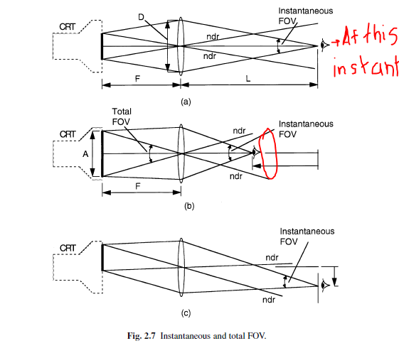

The total field of view is the total angular coverage of the CRT imagery which can be seen by moving the observer’s eye position around. The circular region drawn above is the TFOV. TFOV is determined by

the diameter of the display, *A*,(because the greater the diameter of CRT the greater the angle and so more view space) and effective focal length of the collimating lens, *F*.

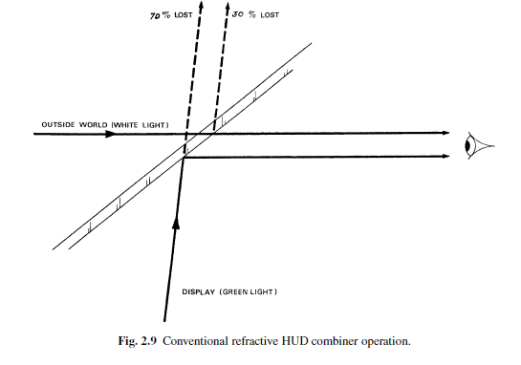

**Holographic HUDs:**

In a modern wide FOV holographic HUD, the display collimation is carried out by the combiner which is given optical power (curvature) such that it performs the display image collimation (Here, the combiner is making the rays parallel which is the function of collimator).

The CRT display is focused by the relay lens system to form an intermediate image at the focus of the powered combiner.

The intermediate image is then reflected from the fold mirror to the combiner. This acts as a collimator as the tuned holographic coating on the spherical surface of the combiner reflects the green light from the CRT display and forms a collimated display image at the pilot’s design eye position.

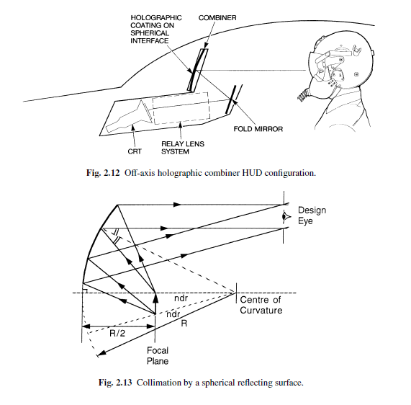

**Parallax:** <https://www.youtube.com/watch?v=B5zKqiaC8QA>

The HUD **reflects light that has been collimated** means that the target markers are projected at infinity just like all other symbols of the HUD and all the light rays are parallel to each other. No matter how much you move your head, the light or the crosswire will appear to be at a fixed spot.

**Design factor (Eyebox**): <https://www.radiantvisionsystems.com/blog/quality-considerations-aviation-head-displays-huds>

To enable collimation and clarity of the display, the user’s eyes cannot be too far outside of an optimal viewing position, defined as the head motion box or “eyebox” area of the HUD system. Move to far left/right, up/down, and the image may not display clearly or fully, or may be distorted. Modern HUDs allow some freedom of movement within an eyebox of roughly 5 inches lateral by 3 inches vertical by 6 inches longitudinally (front to back). For a quality HUD, the pilot needs to be able to view the entire display as long as one eye is inside the eyebox.

## What is serial transmission?

## <https://www.quantil.com/content-delivery-insights/content-acceleration/data-transmission/>

When data is sent or received using [serial data transmission](https://www.reference.com/technology/serial-data-transmission-85a1cf86a6ce29b5), the data bits are organized in a specific order, since they can only be sent one after another. The order of the data bits is important as it dictates how the transmission is organized when it is received. It is viewed as a reliable data transmission method because a data bit is only sent if the previous data bit has already been received. Order of data is mainted.

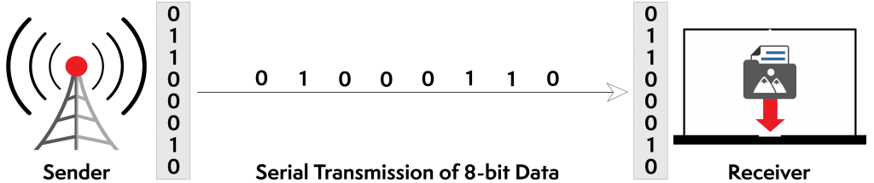

## What is parallel transmission?

When data is sent using [parallel data transmission](http://www.encyclopedia.com/computing/news-wires-white-papers-and-books/serial-and-parallel-transmission), multiple data bits are transmitted over multiple channels at the same time. This means that data can be sent much faster than using parallel transmission methods.

Given that multiple bits are sent over multiple channels at the same time, the order in which a bit string is received can depend on various conditions, such as proximity to the data source, user location, and bandwidth availability. Two examples of parallel interfaces can be seen below. In the first parallel interface, the data is sent and received in the correct order. In the second parallel interface, the data is sent in the correct order, but some bits were received faster than others.

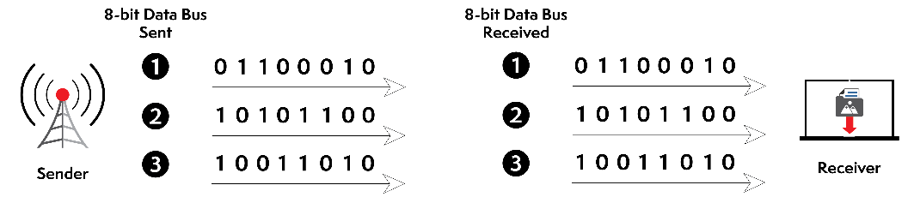

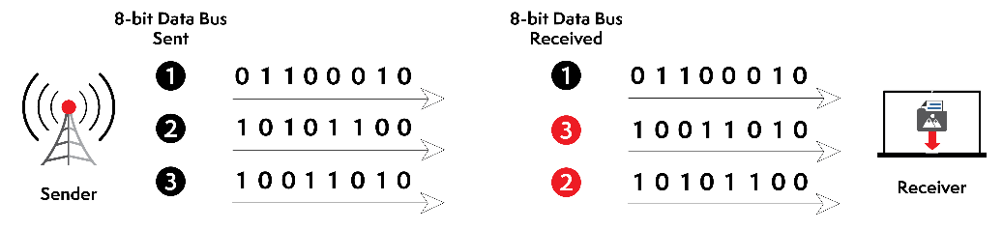

**HUD Electronics: (Page no 23)**

The system may also be configured as two units, namely the **Display Unit** and the **Electronics Unit**.

**The Display Unit** contains the HUD optical assembly, CRT, display drive electronics, high and low voltage power supplies.

**The Electronics Unit** carries out the display processing, symbol generation and interfacing to the aircraft systems. The symbol generator carries out the display waveform generation task (digitally) to enable the appropriate display symbology (e.g. lines, circles, alpha-numeric, etc.) to be stroke written on the HUD CRT. The symbols are made up of straight-line segments joining the appropriate points on the display surface in an analogous manner to a ‘join the dots’ child’s picture book. Fixed symbols such as alpha-numeric, crosses, circles (sized as required) are stored in the symbol generator memory and called up as required. The necessary **D to A conversions (digital to analogue) are carried out in the symbol generato**r which **outputs the appropriate** analogue ***x* and *y* deflection voltage waveforms** and ‘bright up’ waveforms to control the display drive unit of the HUD CRT.

The display drive unit contains all the display drive electronics for the HUD CRT including the high voltage and low voltage power supply units Video interface electronics are incorporated in the display drive electronics for the TV raster mode (i.e. to combine IFLR video)

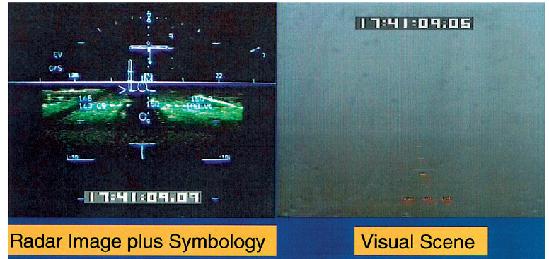

**Wind Shear example:**

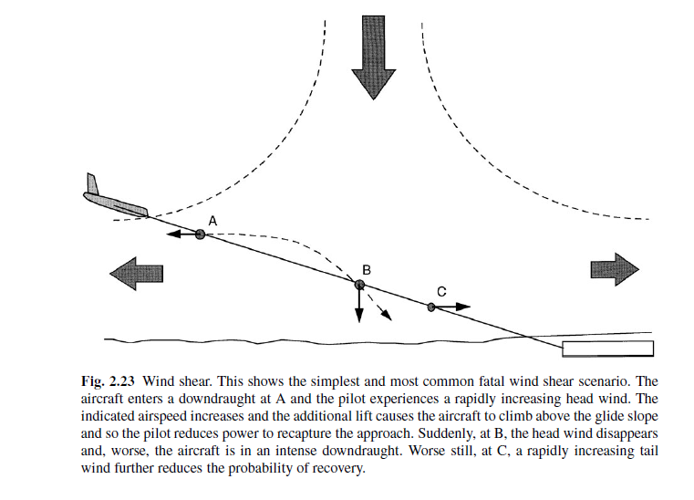

**Advantage of civil HUDs:**

In circumstances, however, during a terrain escape maneuver where the terrain is visible, the flight path vector (FPV) displayed on the HUD provides an unambiguous presentation on whether or not the terrain will be missed. If the FPV is overlaid (lie on top of) on terrain ahead, the aircraft will hit it and in this situation the crew must decide on another course of action as opposed to ‘holding on’ to see what happens.

* An overhead mounted HUD installation is practical in a civil aircraft and is the configuration generally adopted.
* The combiner can fold out of the way when not required.

**Azimuth-Elevation coordinate system:**

This coordinate system is used to find the location of stars, planets, satellites in the sky. The coordinates of stars change as the earth keeps on rotating.

Here, North is the geographical North. Here object is at 140 degrees azimuth and for elevation the object has to be in front of the paper.

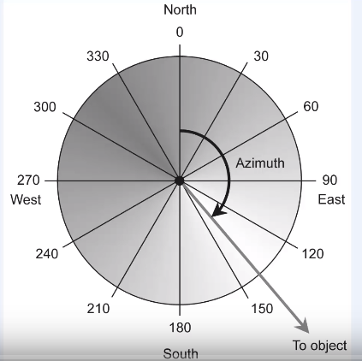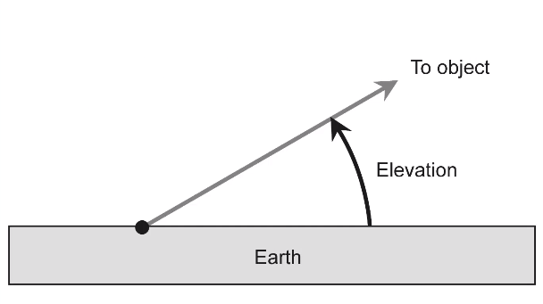

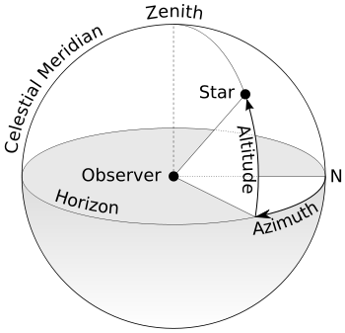

**Reticule:**

A **reticle**, or **reticule** also known as a **graticule** is a pattern of fine lines or markings built into the eyepiece of a **sighting device**, such as a [telescopic sight](https://en.wikipedia.org/wiki/Telescopic_sight) in a telescope, a microscope, or the screen of an oscilloscope, to provide measurement references during visual examination.

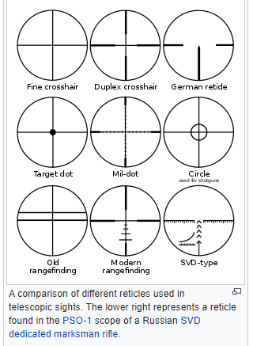

**Predicted impact point (PIP):**

The **predicted impact point** (PIP) is the location that a ballistic projectile (e.g. bomb, missile, bullet) is expected to strike if fired.

**Line of sight:**

The line between the pilot's eye and the [reticle](https://en.wikipedia.org/wiki/Reticle) on the visor is known as the [line of sight](https://en.wikipedia.org/wiki/Sightline) (LOS) i.e. line between the aircraft and the intended target (which is reticle). The user's eye must stay aligned with the sight; in other words, current HMDs cannot sense where the eye is looking, but can place a "[pipper](https://en.wikipedia.org/wiki/Pipper" \o "Pipper)" between the eye and the target.

**Boresight:**

**Boresighting** is a method of visually pre-aligning a [firearm](https://en.wikipedia.org/wiki/Firearm) [barrel](https://en.wikipedia.org/wiki/Gun_barrel)'s [bore axis](https://en.wikipedia.org/wiki/Bore_axis) with the target, in order to more easily [zero](https://en.wikipedia.org/wiki/Sighting_in) (Zeroing is the adjusting the sight so that the projectile will hit the predictable position within the sight).

**Fore and aft axis:**

It is also called longitudinal axis which moves through the fore and aft of an aircraft through the center of gravity.

**Ring and bead (round like water drop) sight:** <https://www.simhq.com/_air9/air_268b.html>

Up to the beginning of world war II (WW2), the most common was the ‘ring and bead’ sight which were fixed.  Note the ring and bead sight mounted in front of the windscreen of this P-40.

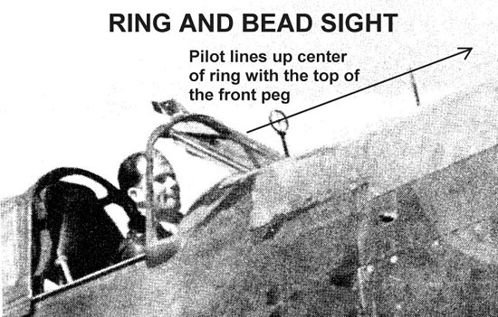 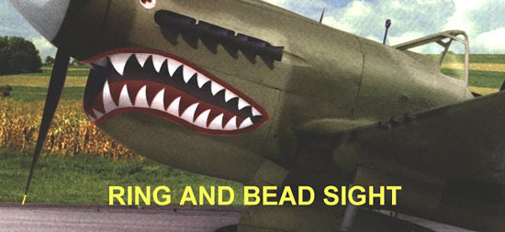

Basic operating principle:

This type of sight was used in the same way a shooter aims a rifle.  A rifle has two sights…a rear notched sight and a front blade sight.  The idea is to aim the rifle with the top of the blade aligned in the notch.  This aligns the shooter’s eye to the barrel gun line.  The shooter then takes that ‘sight picture’ and aims it at the target.  The next drawing shows a typical rifle sight aiming picture.

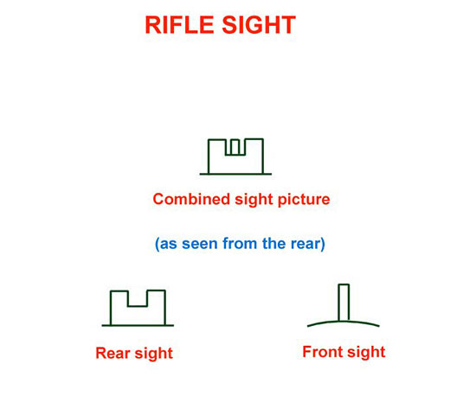

When the pilot aligns the center of the ring with the bead, he is looking down the sight line.

**Targeting:**

If the helmets can't tell where the pilot is looking, many of the airplane's systems, including weapon targeting, are useless.

Instead of having to turn the airplane toward the target to frame it in a fixed-view HUD, the pilot will be able to see targets that are off-axis, or not in the direction of flight.

The fundamental idea behind all HMD/HMS designs is that of using the pilot's Eyeball Mk.1 as a cueing (giving signal) device to direct a missile seeker at a target, to facilitate a rapid lock and missile shot.

**The IDEA OF USING THE PILOT’S HELMET TO POINT A MISSILE SEEKER FIRST ISSUE:**

**Head Position Sensing:**

<https://www.ausairpower.net/hmd-technology.html>

The starting point for the discussion of HMS/HMD designs must be the area of position sensing of head. A position sensing system must be capable of measuring the elevation, azimuth and tilt of the pilot's head **relative to the airframe** (SOMETHING MUST BE THE REFERENCE) with the required accuracy, even during rapid head movement and at some very odd angles. Moreover, this assumes that the helmet "boresight" (DIRECTION AT WHICH HELMET IS POINTING) is the reference direction to which the missiles are to be pointed. Further on this later.

Two basic methods are used in current HMS/HMD technology for head position sensing are:

1. **Optical**

Optical systems employ infrared emitters in the cockpit (or helmet) and position sensing infrared detectors on the helmet (or cockpit), to measure the position of the pilot's head. The principal limitations of this approach is potential sensitivity to sunlight entering the cockpit.

1. **Electromagnetic**

The most popular approach in the West is the use of electromagnetic sensing. Basic physic.

A coil placed in an alternating field will produce an alternating electrical voltage the magnitude and sense of which depends upon the orientation of the coil within the field. If the coil is aligned with the plane of the field, the voltage is at its maximum, if the coil is aligned at a right angle the voltage is zero. In practice a design will use one or more fixed field generator coils within the cockpit to create the electromagnetic field, driven by a high current source, and a sense coil will be embedded in the helmet. The voltage produced by the sense coil is then fed into a black box of electronics which produces the angle measurement. Since we need to generate two or three angular measurements at the same time, we need to double or triple the number of field generator and sense coils, and orient each set at right angles to the other. Sounds complicated? That is not all that is required. A sense coil at some arbitrary angle will be producing voltages from two or three mutually orthogonal fields, yet we need to be able to sort them apart. The simplest approach is to drive the three sets of field coils with slightly different frequencies, and then use notch filters in the electronics to separate the measurements for the three axes. In this manner, all three coils can be used to measure all the fields.

Helmet position measurement of suitable accuracy maketh not a HMS/HMD alone. **WITHOUT THE CROSSHAIR OR RETICLE WE SIMPLY HAS TO EYEBALL THE MISSILE OR LOCKING INTO THE TARGET WITHOUT RETICLE IS ALMOST IMPOSSIBLE.**

**Helmet Optics**

The other important issue is that of providing the pilot with a reference reticle (like crosshair) to place over the target. The direction of the line between the reticle and the pilot's eye is the line of sight (LOS) between the aircraft and the intended target.

The simplest strategy used here is that employed in the US Navy's seventies, which is a simple mechanical "ring and bead" style sight, attached to the front of the helmet. Also, depending on the mounting method, it may move under G load and introduce an unwanted angular error.

For producing the reticle it is rather good to project the reticle than physically producing it. The step up is to use a flat optical combiner glass, and project a simple optically collimated reticle, focussed at infinity. A light source such as an LED with a suitable lense package mounted in the top of the helmet solves this problem.

**UPTO HERE, RETICLE IS PRODUCED AND PROJECTED INTO VICER AND HEAD POSITIONING SENSING IS USED TO GIVE DIRECTION TO RETICLE.**

The other major problematic issue with HMDs is that the user must keep his/her eye always aligned with the sight (TARGET), and thus the natural combination of head and eye movement used to track a moving object must be unlearned, and a new "head only" tracking motion learned. Since the position of the helmet is what is used to point the missile, pilots will have to develop even greater neck musculature.

Another idea is being in research i.e. from the virtual reality world which could prove to be useful for HMD designs is eye tracking, or sensing the direction the eyeball is looking at, relative to the direction of the head.

**Infrared guided missile (IR):**

More modern infra-red guided missiles can detect the heat of an aircraft's skin, warmed by the friction of airflow, in addition to the fainter heat signature of the engine when the aircraft is seen from the side or head-on.

Start of the 21st century missiles such as the [ASRAAM](https://en.wikipedia.org/wiki/ASRAAM) use an "[imaging infrared](https://en.wikipedia.org/wiki/Imaging_infrared)" seeker which "sees" the target (much like a digital video camera), and can distinguish between an aircraft and a point heat source such as a flare. They also feature a very wide detection angle, ***so the attacking aircraft does not have to be pointing straight at the target for the missile to lock on. The pilot can use a***[***helmet mounted sight***](https://en.wikipedia.org/wiki/Helmet_mounted_sight)***(HMS) and target another aircraft by looking at it, and then firing. This is called "off-***[***boresight***](https://en.wikipedia.org/wiki/Boresight_(firearm))***" launch.*** For example, the Russian [Su-27](https://en.wikipedia.org/wiki/Su-27) is equipped with an [infra-red search and track](https://en.wikipedia.org/wiki/Infra-red_search_and_track) (IRST) system with [laser rangefinder](https://en.wikipedia.org/wiki/Laser_rangefinder) for its HMS-aimed missiles.

* All the weapon system are slave the HMD, pilot just have to turn his head lock the target and shoot.
* For situational awareness, critical mission data is projected in HMD and which is superimposed to the outside world with no parallax error.
* If pilot have to land at night on snow or sand, HMD gives the virtual view of the terrain, shows obstacles, corrects any drifts.
* ***WEAPON AIMING BY HEAD TRACKING SYSTEM EXAMPLE IN THIS VIDEO: 1:29***

<https://www.youtube.com/watch?v=DnohuheUZ9w>

Reticle glass for rifle:

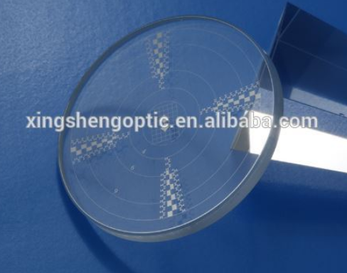

**Optical sights** use [optics](https://en.m.wikipedia.org/wiki/Optics) that give the user an image of an aligned aiming point (or pattern also called a [reticle](https://en.m.wikipedia.org/wiki/Reticle)) superimposed at the same focus as the target.

**Parallax:**

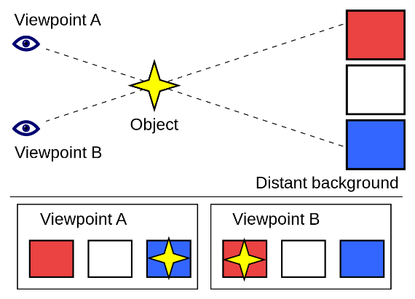

Like in scale where the marking in done on the upper surface. To make accurate reading, the reading must be done by keeping the eye above the marking, if not done the position of marking will be displaced.

Like above, white is the actual position but when seen through an angle the object image is displaced.

**Sight alignment: (Center:-rear and Center:-front)**

<https://www.youtube.com/watch?v=9gyO5QrYzNw&t=17s>

In gun, the trigger side is the rear side and nozzle side is the front side.

Sight alignment is the alignment of front sight in the rear sight aperture.

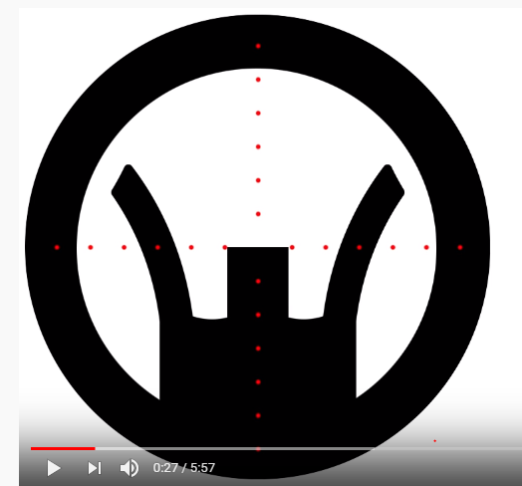

Here, aperture or circular part is the rear part and cross hairs represent the middle of rear sight aperture. Then, we line the front sight up in the middle of the rear sight aperture center center.

**Sight Picture: (Center:-rear, Center:-front and Center:-target) Also CENTER MASS**

Sight picture is bringing the aligned sight on to the target.

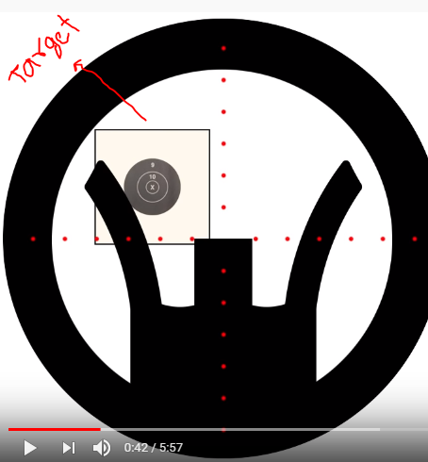 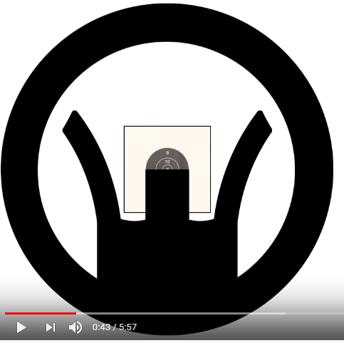

**Eye Focus:**

Eye cannot focus on mor than one thing at a time. So, focus must be done on the front side.

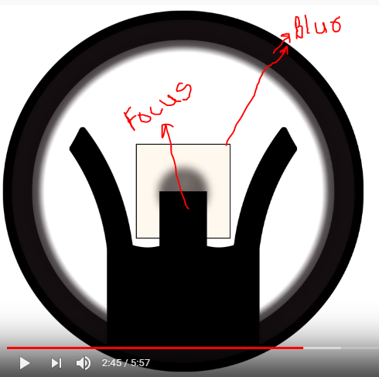

A **collimator sight** is a type of [optical sight](https://en.m.wikipedia.org/wiki/Sight_(device)#Optical_sights) that allows the user looking into it to see an illuminated aiming point aligned with the device the sight is attached to, regardless of eye position

**Weapon aiming tutorial:**

When missile guidance system is turned on then the circular cross hair appear, where circle showing where the sensor of missile is pointing. We can lock to a target upto 90 degrees off the shoulder. It takes some small time to be in sight to the missile cross hair with eyesight cross hair. To lock the target, put the circle in the enemy aircraft and cage uncage button

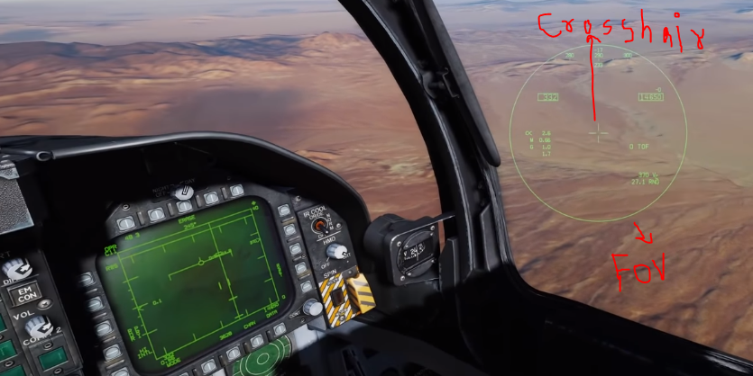

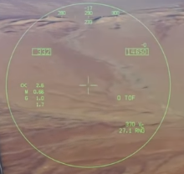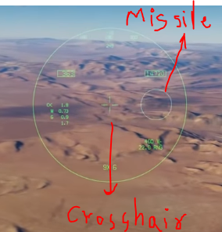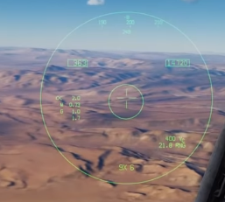

**Caged and uncaged missile:**

Uncaged missile once launch finds the target, lock it and hit it by flying toward it. Advantage of uncaging is that you don’t have to keep the target directly in the front position of missile where caged/boresighted seeker can see it.

Caged missile function is used when the target is in the seeker’s (missile type which have the capability of finding, maneuvering and hitting) boresighted position (i.e. missile axis position).

**Monocular Vision:**

**Monocular vision** is [vision](https://en.m.wikipedia.org/wiki/Visual_perception) in which both [eyes](https://en.m.wikipedia.org/wiki/Human_eyes) are used separately. By using the eyes in this way, as opposed to [binocular vision](https://en.m.wikipedia.org/wiki/Binocular_vision), the [field of view](https://en.m.wikipedia.org/wiki/Field_of_view) is increased, while [depth perception](https://en.m.wikipedia.org/wiki/Depth_perception) is limited. The eyes of an animal with monocular vision are usually positioned on opposite sides of the animal's head, giving it the ability to see two objects at once.

Monocular rivalry means 2 different images in 2 eyes so make difficult to focus.

**CRT monitor:**

CRT monitor displays color picture by using combination of phosphors that emit different colored light.

One technique for producing color displays with CRT is by beam-penetration method.

Beam-penetration method
● for displaying color pictures has been
used with random-scan monitors
● Two layers of phosphor, ...

**Night vison vs IFLR:**

<http://www.differencebetween.net/technology/difference-between-night-vision-and-infrared/>

Night vision goggles work by collecting what little amount of light is available and amplifying it so that it can be discerned by the naked eye. **Infrared is a new technology employed with**[**night vision goggles**](http://www.differencebetween.net/object/difference-between-goggles-and-sunglasses/)**.** Rather than employing visible light and amplifying them, infrared goggles rely on infrared waves that are emitted by anything that emits heat. The difference in temperatures between objects provides the contrast to identify between different objects.

Because night vision goggles amplifies available light that bounces off of objects, no light means no amplified image. Since infrared goggles do not rely on ambient light, they do not suffer from the same problem. Objects emit their own infrared light with amounts varying according to how much heat that body has. Infrared goggles can be used with even in total darkness.

The biggest advantage between the usual night vision and infrared goggles is that the latter is much better at spotting at objects that are partially or totally hidden. A person hidden inside a cardboard box or behind some bushes can be hard to see with the naked eye. With infrared, their heat signature would go through the covering material and be clearly visible to the infrared goggles.

Read more: [Difference Between Night vision and Infrared | Difference Between](http://www.differencebetween.net/technology/difference-between-night-vision-and-infrared/#ixzz68j5PhERW) <http://www.differencebetween.net/technology/difference-between-night-vision-and-infrared/#ixzz68j5PhERW>

**Night Vision Googles:**

However, at night, far fewer visible light photons are available and only large, high contrast objects are normally visible. Fine detail and low contrast objects are not resolvable by the human eye; its photoreceptors (rods and cones) must receive large numbers of visible light photons to register an image.

Therefore, at night, more light is available in the near IR than in the visual band and that against certain backgrounds, notably green vegetation, more contrast is available. Image intensifiers provide a means of taking advantage of this situation by effectively amplify ing the available near IR light and presenting the user with an image that is sufficiently bright to be clearly visible without their being dark adapted

Night vision goggles use available red and infrared (IR) light from sources such as the stars, moon and the night sky, intensified sufficiently to be presented to the eye as a visible image. All night vision goggles operate on the same basic principle and use image intensifier tubes (IIT) to produce a bright monochromatic (typically green) electrooptical image of the outside world in light conditions where the unaided eye can see little or nothing.

**Night Vision Goggles Configuration**

This biocular approach was found to be unsuitable for the demanding airborne environ ment so airborne NVGs use two IITs to provide the pilot with a binocular view of the night scene.

Typically, an airborne NVG comprises two monocular assemblies mounted on a bracket that is attached to the front of the pilot's flying helmet. Typically, an airborne NVG comprises two monocular assemblies mounted on a bracket that is attached to the front of the pilot's flying helmet.

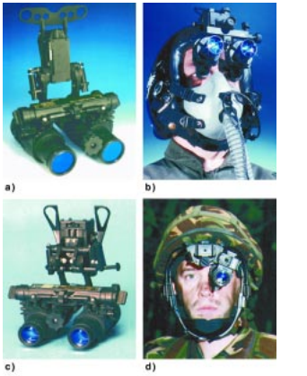 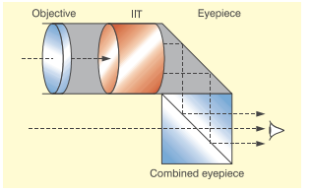

Each monocular assembly has an objective lens that collects the available IR light from the outside world and focuses it onto the IIT input window (fig. 5). The objective lens also normally contains a `minus blue' filter for compatibility with blue/green cockpit lighting. The electrooptical image is then relayed to the pilot's eye by an eyepiece assembly. Conventionally, these components are mounted directly in line with the pilot's lineofsight.

**Optical Image Combination**:

This technique involves optically combining the output of a helmet mounted CRT or other display device with the output of the image intensifier tube (same as in parallel and light from moon means from outside world) at a single intermediate image plane.

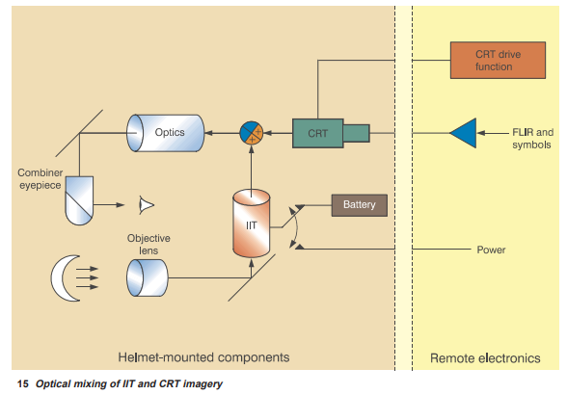

FLIR from CRT using Infrared light i.e. something like heat and Below apparatus in night google using the available red light close emitted at night.

**Charged Couple Device:** <https://techterms.com/definition/ccd>

Stands for "Charged Coupled Device." CCDs are sensors used in [digital](https://techterms.com/definition/digital) cameras and video cameras to record still and moving images **(USED IN CAMERAS BUT NOT USED TO CAPTURE VIEDO FILMS).** ***The CCD captures light and converts it to digital data that is recorded by the camera.*** For this reason, a CCD is often considered the digital version of film.  it captures and stores images in digital memory.

The quality of an image captured by a CCD depends on the [resolution](https://techterms.com/definition/resolution) (Resolution measures the number of [pixels](https://techterms.com/definition/pixel) in a [digital](https://techterms.com/definition/digital) image or display) of the sensor. Therefore, an 8MP digital camera can capture twice as much information as a 4MP camera. The result is a larger photo with more detail.

CCDs in video cameras are usually measured by physical size. For example, most consumer digital cameras use a CCD around 1/6 or 1/5 of an inch in size. More expensive cameras may have CCDs 1/3 of an inch in size or larger. The larger the sensor, the more light it can capture, meaning it will produce better video in low light settings. Professional digital video cameras often have three sensors, referred to as "3CCD," which use separate CCDs for capturing red, green, and blue hues.

The beauty of CCD cameras is that it provides a low-noise, high quality image at a highly pixilated resolution.

Monocular and binocular head mounting display:

Image produced may be:

1. Monocular (for single eye).
2. Binocular (displayed on both eye).

Binocular head mounted display unit project an image of displayed information in the direct line of sight and center filed

**Sterepsis:** <https://www.youtube.com/watch?v=ghSR2bI5YSE>

<https://www.youtube.com/watch?v=P9egHhipgng&t=29s>

If the eyes are working together, then the brain is able to blend (mix with another substance so they combine together) the separate images from each eye into one image the child can perceive (see) three dimensional space and is said to have **stereopsis or binocular vison.**

**=**

And in child whose eyes are not working together the brain is unable to blend the separate images from each eye. Final image seen by brain as it is unable to combine two images.



Experiment: Point one finger stretched in front of eye and close each eye and see, position of finger changes. Brain uses two different images i.e. one image of left eye with the image seen by right eye to combine them to give the sense of depth perception. **PERCEPTION OF DEPTH ARISES DUE TO BINOCULAR VISON.**

**To see a movie in 3d there have to be two images projected onto the screen. One from the perspective of left eye and one from the perspective of right. You wear glasses that channel the left image to the left eye and right image to the right eye. And as in the real world your brain goes to work to process called stereopsis so the two images combines to a single three-dimensional image.**

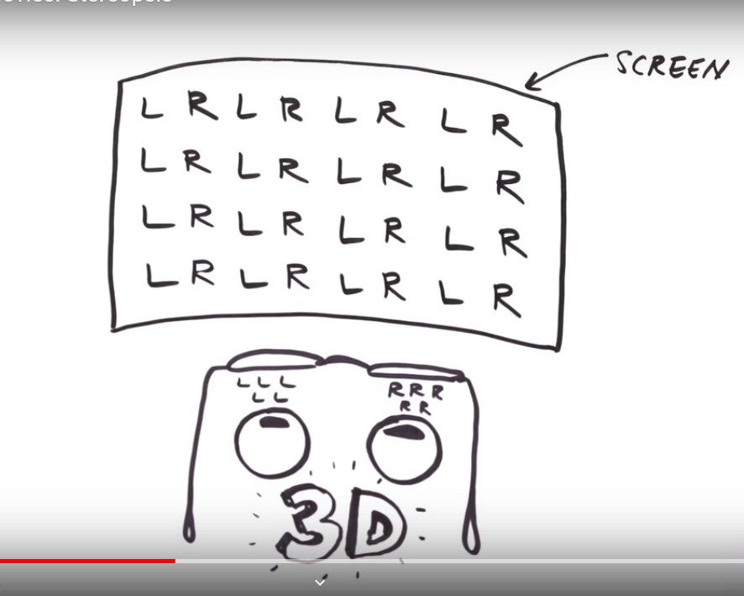

**Retinal Projecton:**

A **virtual retinal display** (**VRD**), also known as a **retinal scan display** (**RSD**) or **retinal projector** (**RP**), is a display technology that draws a [raster](https://en.wikipedia.org/wiki/Raster_graphics) display (like a [television](https://en.wikipedia.org/wiki/Television) where image are formed by pixel) directly onto the [retina](https://en.wikipedia.org/wiki/Retina) of the eye or project image directly into retina. The user sees what appears to be a conventional display floating in space in front of them.

Here, light is shining a light at a level of brightness that’s safe for the eye.

**God’s eye view:**

Pilot can see the as he was outside the aircraft into all direction making it realistic. The threat situation can be presented on such a ‘God’s eye view’ display – e.g. enemy aircraft, missile sites, anti-aircraft artillery (‘Triple A’) sites or enemy radar sites. Threat zones defining the missile (or gun) range, radar field of view, etc., can be presented as 3D surfaces so that the pilot can assimilate the threat situation on a single display.

Figure 2.33 shows a 3D ‘God’s eye view’ display which provides the pilot with

a stereoscopic view of his helicopter as well as its relationship to its proposed flight

path. Further information can be provided by enabling the pilot to change his apparent

position outside the aircraft.

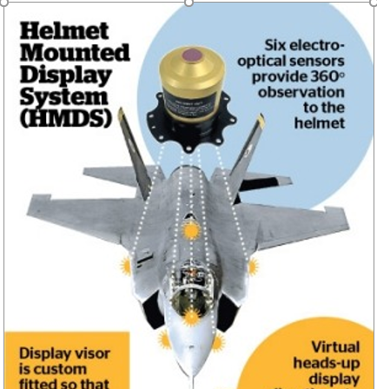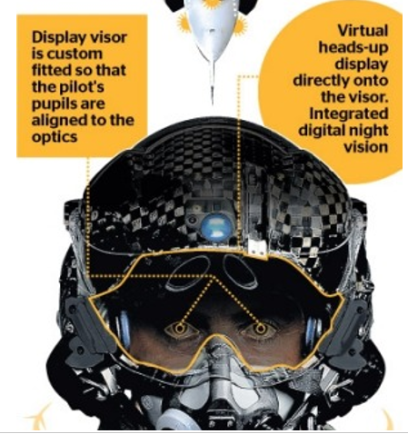

**Stability augmentation System:**

CHAPTER 4

AUTOMATIC FLIGHT CONTROL AND STABILIZATION SYSTEMS

Pilot must be continually up-to date with the performance of the aircraft. And, pilot can now take the required action to get the desired performance. In high performance aircraft, especially single-piloted aircraft, other flight duties require much of the pilot’s time. Navigation, communication, radar, and other special equipment are severely limited (can’t give enough time for special equipment) if the pilot has to work continually on the physical manipulation of the controls (for maintaining stability of aircraft).

In high-performance aircraft capable of supersonic flight, aircraft speed is so great that the pilot’s normal response time is far too slow. For example, by the time the pilot reacts to an indicator to position a control surface, the aircraft may already be out of control.

Automatic flight control and stabilization systems ease the pilot’s workload and provide aircraft stability at all speeds. The information now flows directly to a flight control computer rather than to an indicator. This action lessens the time required to start a control movement to nearly zero. The result is increased stability.

Some automatic flight control systems are capable of flying the aircraft by radio navigation aids, correcting for wind, and making pilot-unaided landings.

The term Automatic Flight Control System (AFCS) is used instead of the older term, automatic pilot, or the shortened version, autopilot. A reliable AFCS is necessary because pilots have duties other than moving the flight controls. However, regardless of how sophisticated the AFCS computer may be, the reasoning power of the pilot cannot be duplicated.

**overshoot** is the increased amplitude of a portion of a signal at the output of a non-linear circuit

**Stability:** <https://www.ausairpower.net/AADR-FBW-CCV.html>

A conventional aircraft, with a large degree of natural stability, can be represented, generally, as a system comprised of three basic elements - the pilot, the controls, the vehicle itself. Their interaction determines the function of the system. The path of this interaction is evident from the diagram - the pilot inputs commands via the controls; the vehicle, in turn, responds. The pilot then receives information, by visual cues from the attitude sensors (e.g. artificial horizon) and/or the external world, as to the exact nature of the response, enabling him to correct.

Thus the pilot and aircraft are engaged in a feedback loop, the pilot guiding the aircraft through its mission and also correcting unwanted deviations generated by the natural behaviour of the aircraft. Stability can be broadly defined as a system's ability to return to its initial state after receiving some stimulus.

**Static stability** can be described as a measure of an aircraft's ability to return to its level attitude, following (after doing) some change in attitude. In a statically stable aircraft, a change in attitude generates restoring forces, which oppose the change.  The restoring forces in the statically stable aircraft act as long as its attitude differs from level (original orientation).

Acceleration is also the change i.e. change in velocity or direction of aircraft. So, after acceleration of aircraft, force will be acting in the aircraft due to the stability to be maintained. So, this acceleration will cause the aircraft to swing back and overshoot (increase in amplitude), generating in turn another set of restoring forces, with identical effects. The aircraft will swing back and forth, if it's dynamically stable the overshoot will get smaller and smaller till it dies off, if it's unstable the overshoot will get greater with every cycle, throwing the aircraft out of control.

Handling qualities of an aircraft are given by its stability.

Too much stability results in a sluggish, unresponsive machine, with large control forces, (like the sensitivity on the mouse during playing game is too low then by displacing more mouse will result in small change BUT IN AIRCRAFT THE LESS DISPLACEMENT ON TOO MUCH STABLE WILL BE DUE TO BIG RESISTING FORCE TO CHANGE ITS ATTITUDE) **on the other hand** too little is characterized by overresponsive, sensitive controls (LIKE HIGH SENSIVITY MOUSE WHERE SMALL MOVEMENT WILL CAUSE MUCH DIPLASEMENT OF CURSOR).

The lower the natural static stability of the aircraft, the larger the number of corrections required, thus diverting attention from other tasks. This doesn't last forever, because there comes a point where the pilot himself can no longer respond fast enough to make the appropriate correction, with that degree of instability the aircraft becomes unflyable.

The aircraft, being statically unstable, deflects from its level attitude (e.g., the effect of a short gust). Little or no restoring forces are generated to impede the process. When this occurs, the attitude rate sensors detect the motion and generate a corresponding signal. This signal is received by the flight control computer (FCC), which compares it with the output signal generated by the cockpit controls. In this instance, the FCC recognizes the output for level flight and actuates the corresponding control surfaces to correct. In the manner the FCC, vehicle and rate sensors are locked into a feedback loop - the FCC and rate sensors generating the whole system's stability - hence the term **artificial stability.**

**Flight Control Computer:**

**FCC modifies the pilots inputs in accordance with carefully developed and validated software programs in order to produce max operational effect without compromising safety.**

Pilots commands are converted to electrical signal and are passed to the FCC which determines how best to move the actuators at each control surface to provide the desired response. (To complete on command (roll at 5 degree per sec), here not only a aileron are used but flaps and other control surface may be used and which control surface to be used to fulfill the pilot command is decided by FCC.

The computer monitors the aircraft’s response to the flight control movements and **modifies its output** to the powered flight control unit as required.

All Airbus aircraft since the A320 series have used FBW control and for Boeing 777 and later designs.

The main concerns with FBW system is reliability. While traditional mechanical or hydraulic control system usually fail gradually, but loss of a FCC could immediately render the aircraft uncontrollable. For this reason FBW systems incorporate either multiple redundant computers, some kind of mechanical or hydraulic backup or combination of both.

Side sticks or **conventional control yolks or wheels** are used in FBW aircraft. The side stick offers the advantages of being lighter, mechanically simpler and unobtrusive (provide no obstruction).

Boeing use conventional yokes in their fly by wire designs.

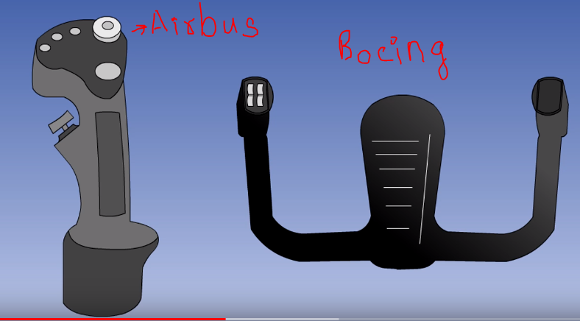

Airbus A320 FBW system:

7 computers and three hydraulic systems looking after the primary flight control (which controls the control surfaces). Each primary flight control has two hydraulic actuators, each fed from one of three independent hydraulic system.

* There are two **elevator aileron computers** (ELAC). These controls the elevators, ailerons and stabilizer. Only one of these computer is controlling at any time (Other is backup).
* There are three **spoiler elevator computers** (SECs). And in the event of failure of both ELAC they will also control the elevators and stabilizer.
* Although, the pilot controls the rudder through a conventional hydro mechanical system. There are also two **flight augmentation computers** (FACs) which operate the rudder to automatically give roll assistance.
* Stabilizer trim is hydraulically operated. It can be mechanically controlled by the pilots trim control wheel.
* ELACs and SECs system has both electrical and hydraulic redundancy built into it. Elevator and ailerons have access up-to 5 computers. Only one of which is needed for them to operate.

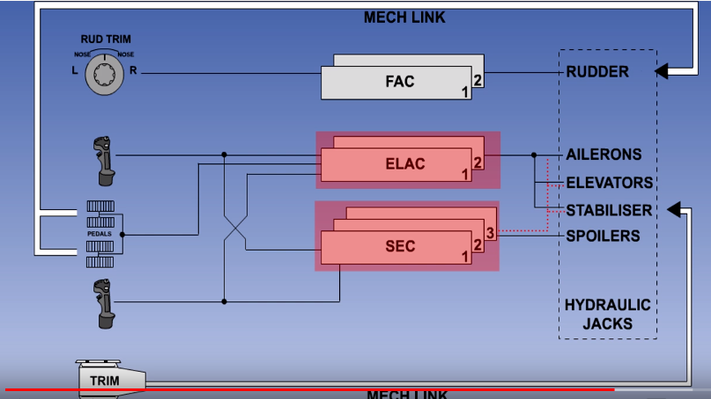

3 hydraulic systems. Each surface can be operated by either one or two systems. Even if two of the hydraulic system fail, the aircraft will still be controllable.

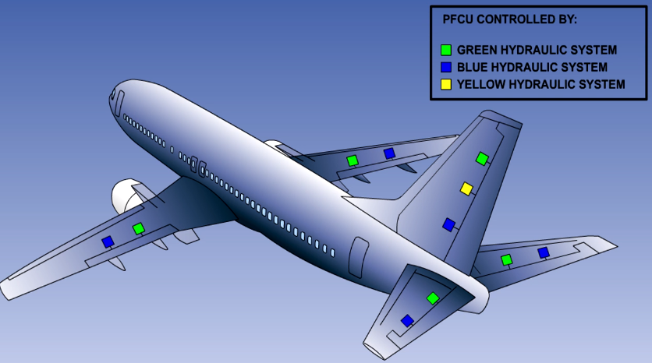

In the case of total electrical failure, the aircraft can be controlled longitudinally with the trim wheel and laterally with the rudder pedals. Both of which operate their control surfaces hydro-mechanically.

**Data redundancy** is defined as the storing of the same data in multiple locations. An example of data redundancy is saving the same file five times to five different disks.

Redundant sources means data from different sources so that no wrong information is taken.